Local Search Engine

2020-07-28

Leader: Garrett Jennings (10805100) Module: User control

**1.Objectives**

Import plain text into a database, indexing the files, and providing a search interface for them. An administrative user will have authorities to import, modify, and delete files.

**2. Overall architecture — 20 points**

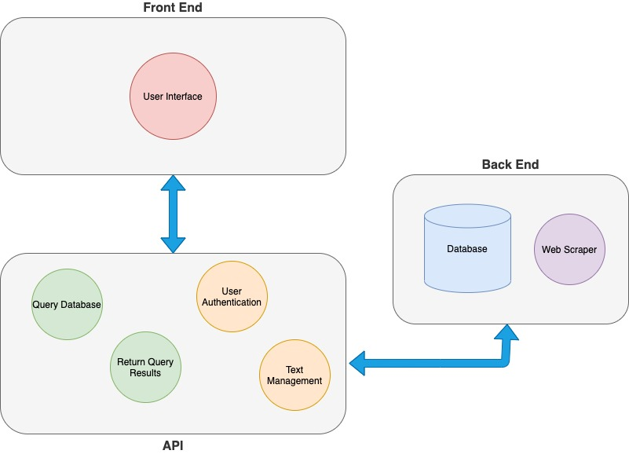

Figure 1 Overall architecture of the local search engine

There are three major parts of the system that contain the applications and the interfaces of the system. On the front end of the system, the technical and end users will see an interface that allows them to interact with the system without having to code into the system. These user interfaces allow the users to search, select, and read files that are contained in the database. The technical users are able to use the interface to make changes to the database without having to access the code for the system.

The API of the system is where all of the applications and the programs that interpret the user commands and pass them to the database. The applications and codes in the API also allow the database to return the results of the user queries to the users in the front-end interface. This helps the user to see the results that they want to see in an easier to read way. The API also contains applications and programs that ensure that the admin user for the system is signing in using the correct information. These applications allow the system to make sure that the admin user is being authenticated by the system so that only authorized users will change the items in the database.

On the back end of the system, the database and a webscraping software exist to help ensure that the database has text in it to be searched. The database is managed by MySQL, and the commands passed through the API can make searches, add items, delete items, and display the items from the databse in the front-end interface.

**3. System Design**

**3.1. System Flow — 10 points**

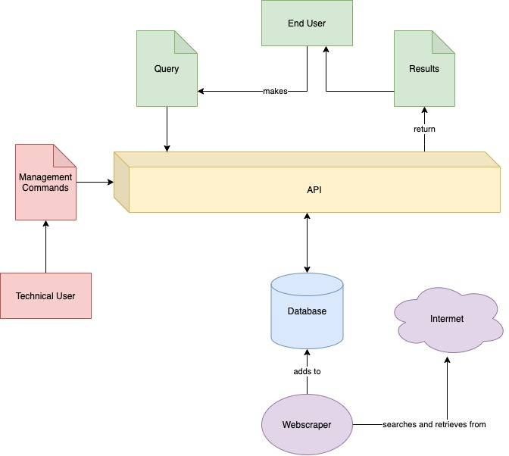

**3.2 System functions — 30 points**

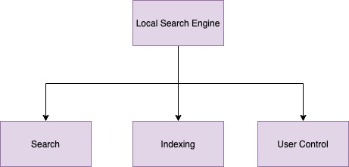

(1) Search

The search function of the system allows the end user to make searches from the system anonymously. The part of the system takes a query from the user, runs it to the database, and then returns the results of the search. This function also returns the results in a format that is easily read by the user. Once the user chooses the file that they want to read that matches their needs, the system will return the file that the user has chosen in a display that the user can easily read.

(2) Indexing

The indexing function of the system is where the administrative user of the system can use the front-end interface to modify and delete the entries in the database. This function also allows the system to scrape files from the internet to include new files in the database.

(3) User Control

The user control function is where the information about the administrative user of the system is housed. This function authenticates the user to ensure that only the person that is authorized to login to the system is making changes to the database. The administrative user can change their password if it is forgotten, or if there is a change to the administrative user for the system. The function also ensures that the security question and answer are the correct ones, and it authenticates them before it allows the user to change their password.

**3.3 Database Design -- 20 points**

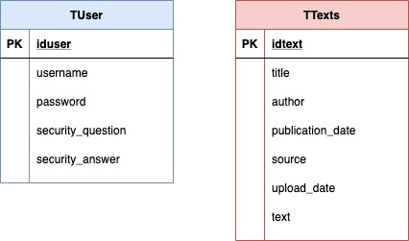

Table 1. TUser

|  |  |  |  |  |
| --- | --- | --- | --- | --- |
| Field | Data Type | Main Key | Foreign Key | Desc |
| iduser | Int | X |  | This is an id for the user that is specific to this user only. |
| username | varchar(45) |  |  | The username of the user. |
| password | varchar(45) |  |  | The user’s password. |
| security_question | varchar(100) |  |  | The security question of the user. |
| security_answer | varchar(100) |  |  | The answer to the security question. |

Table 2. TText

|  |  |  |  |  |
| --- | --- | --- | --- | --- |
| Field | Data Type | Main Key | Foreign Key | Desc |
| idtext | int | x |  | This is the specific id for the text. |
| title | varchar(45) |  |  | Title of the item in the database. |
| author | varchar(45) |  |  | Author(s) of the text. |
| publication_date | date |  |  | Date that the text was originally published. |
| source | varchar(150) |  |  | Source of the data. |
| upload_date | datetime(6) |  |  | Date added to the database. |
| text | longtext |  |  | The text stored for retrieval in the database. |

**4. System Testing—20 points**

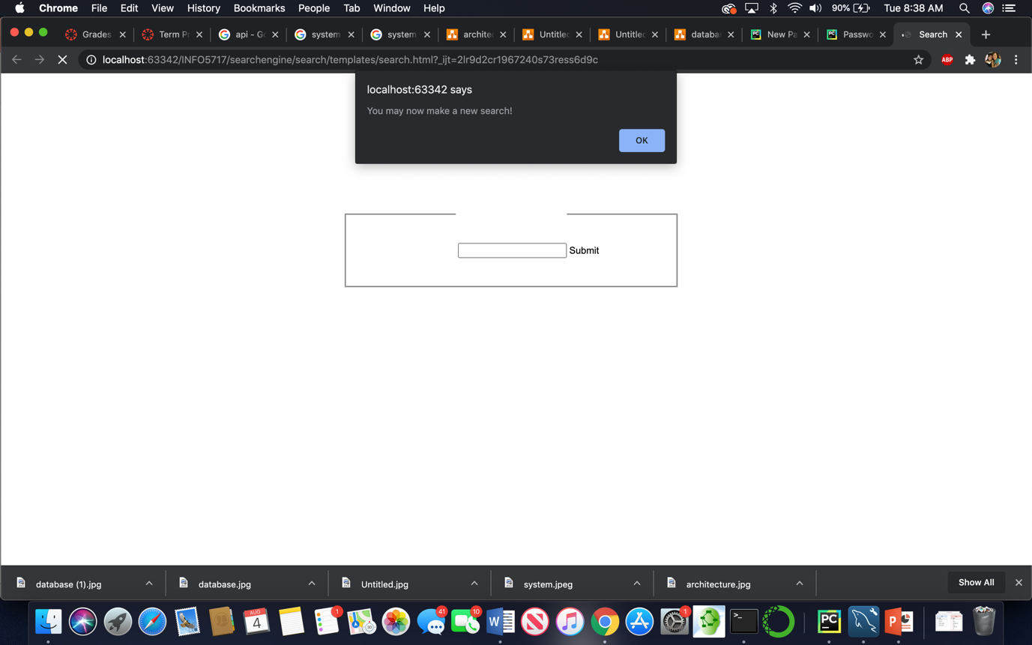

When the user first gets into the system to make a search, they will be prompted that they can make a new search. Then they will have the option to search the system. There is also a button at the top of the screen that allows the administrative user to sign in.

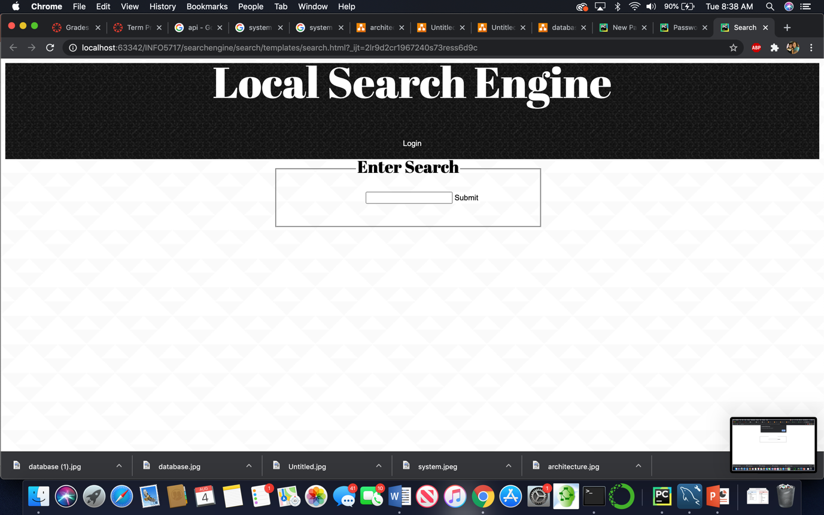

When the user makes a search, they will be given a list of options that match their search from which to choose.

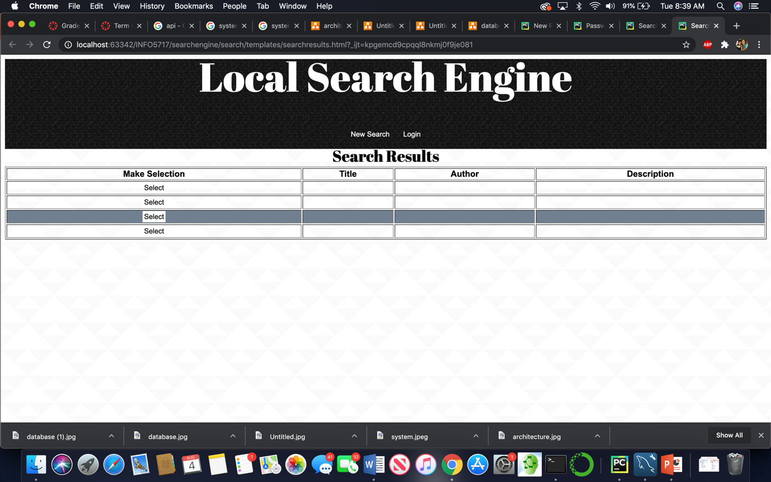

Once the user decides which choice they would like to see, they should select it. This selection will then be displayed.

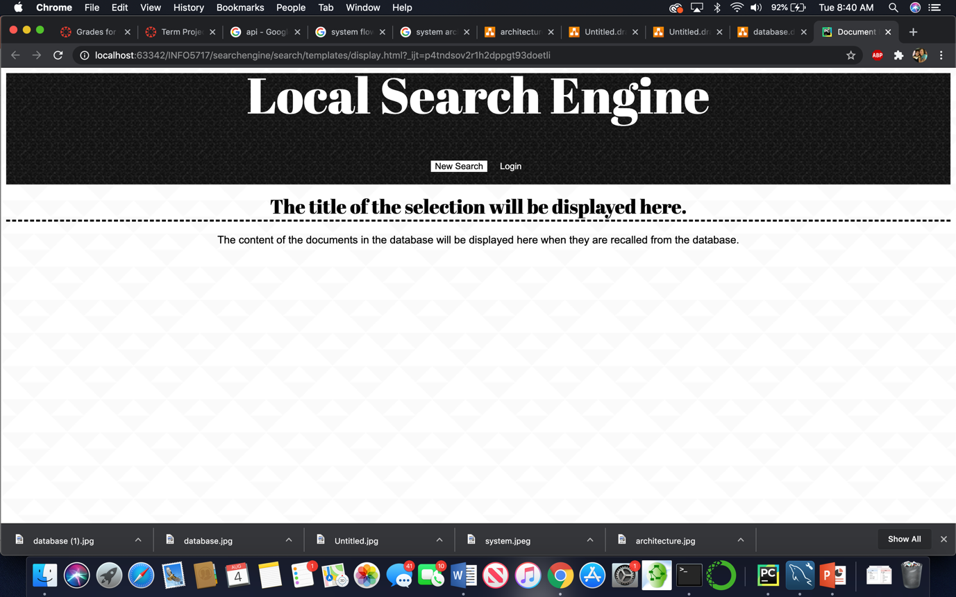

At any time, the user can press the New Search button to go back to the search page. They can also choose to login as the administrative user. If the Login button is pressed, then the user is prompted that they should only attempt to login to the system if they are authorized to do so.

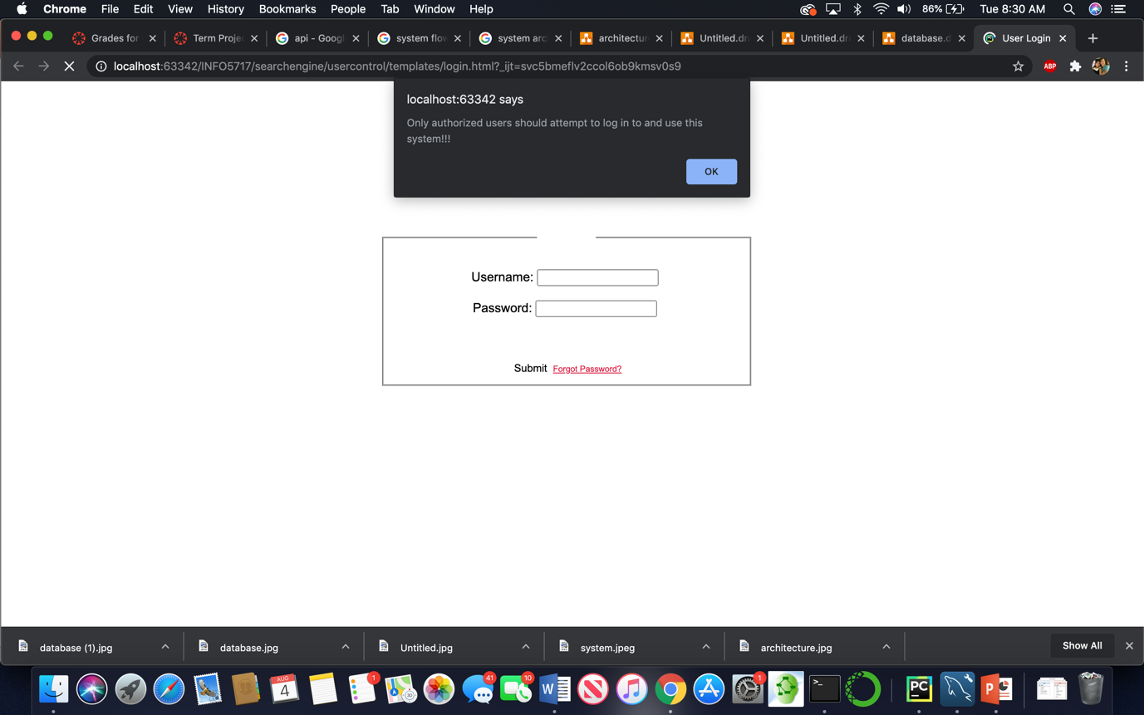

Once they acknowledge this, then they are allowed to login.

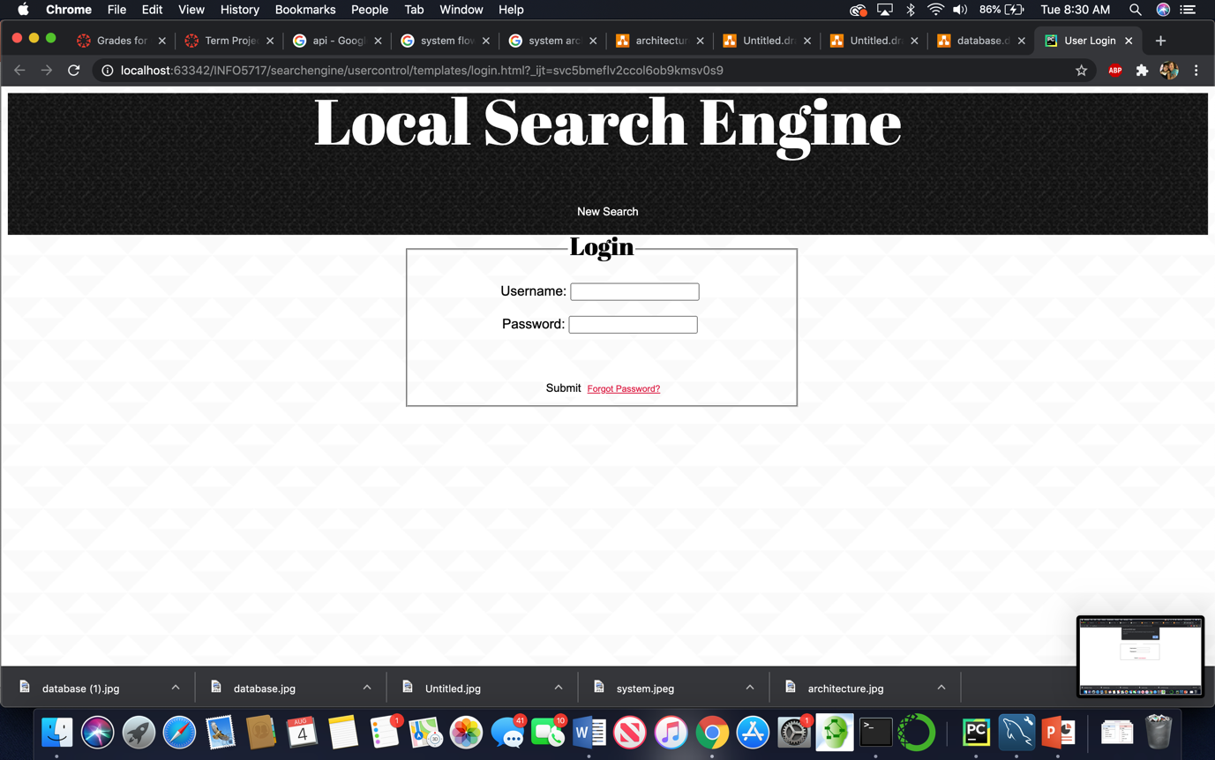

Once the user has logged in to the system, they are automatically taken to the text management page so that they can make changes to the database.

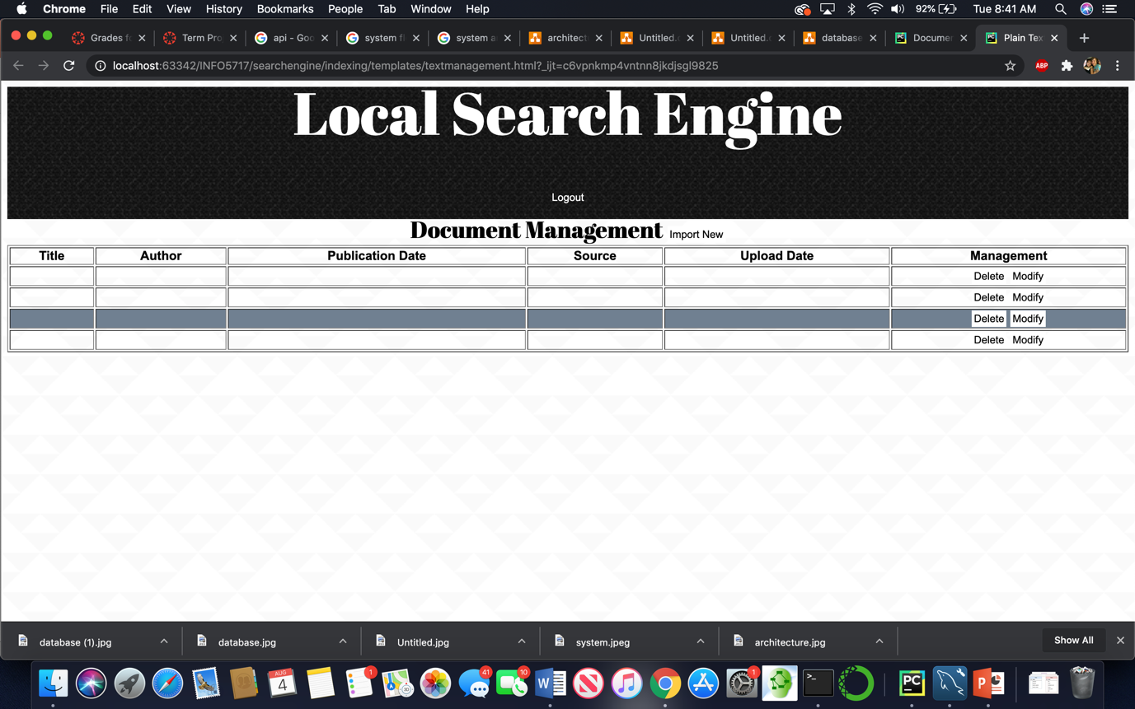

If the user has forgotten their password, then they can click the link that says “Forgot password?”. They will be taken to a screen where they can verify their identity using their security question.

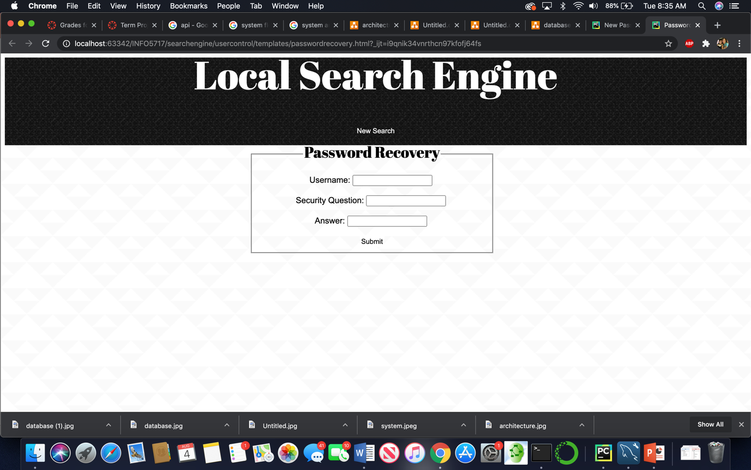

As long as they are able to verify their identity, the user will be taken to the screen where they can change their password.

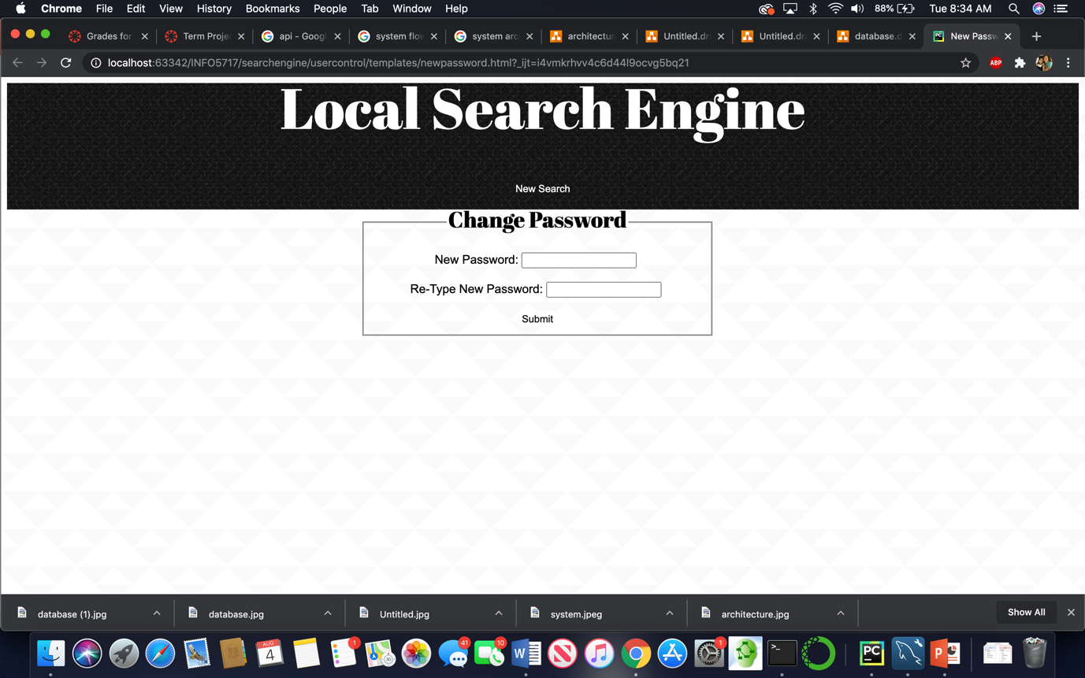

Once the user has changed their password, it will be updated in the user database table and the user will be taken back to the login screen to login to the system.